Software Requirements Specification
for
TicketR (Ticket booking web application)

Version 1.0 approved
Prepared by
20k-0275 Syed Abdullah | BCS-5A
20k-0278 Muhammad Ayyan Tahir | BCS-5A
20k-0315 Taha Khan | BCS-5A

Table of Contents
Table of Contents ii
Revision History ii
1. Introduction 1
1.1 Purpose 1
1.2 Document Conventions 1
1.3 Intended Audience and Reading Suggestions 1
1.4 Product Scope 1
1.5 References 1
2. Overall Description 2
2.1 Product Perspective 2
2.2 Product Functions 2
2.3 User Classes and Characteristics 2
2.4 Operating Environment 2
2.5 Design and Implementation Constraints 2
2.6 User Documentation 2
2.7 Assumptions and Dependencies 3
3. External Interface Requirements 3
3.1 User Interfaces 3
3.2 Hardware Interfaces 3
3.3 Software Interfaces 3
3.4 Communications Interfaces 3
4. System Features 4
4.1 System Feature 1 4
4.2 System Feature 2 (and so on) 4
5. Other Nonfunctional Requirements 4
5.1 Performance Requirements 4
5.2 Safety Requirements 5
5.3 Security Requirements 5
5.4 Software Quality Attributes 5
5.5 Business Rules 5
6. Other Requirements 5
Appendix A: Glossary 5
Appendix B: Analysis Models 5
Appendix C: To Be Determined List 6

Revision History
Name | Date | Reason For Changes | Version

Introduction

Purpose

The purpose of this document is to provide a detailed view of the project we have built for this course

Document Conventions
Font style: Arial.
Font size: 10
Font decoration: none.

Font Style (Headings) : Times.
Font size: 14,18
Font decoration: Italic, and Bold.

Intended Audience and Reading Suggestions

The Course Instructors or any other person who is connected to this field or finds this project relevant to his needs.

Product Scope
TICKETR grants the probable users to book and pay for an event ticket directly through the website. All stages of bookings from choosing an event to making a seat reservation at the venue , are handled online which considerably reduces the staff-workload and the struggle of buying tickets by getting in long queues.

References
WEBSITES:

https://www.perforce.com/blog/alm/how-write-software-requirements-specification-srs-document
https://www.geeksforgeeks.org/software-requirement-specification-srs-format/

Overall Description

Product Perspective
The TicketR web application is basically designed to provide a functionality to facilitate online ticket booking for events happening nearby (music concerts ,drama etc.) .The users can be Customer and Organizer. Customers are able to book tickets for an event and the Organizers can list their own events on the website and sell tickets . Further the admin is able to add/update the events listed by the organizers and add/update the user records from the system.

Product Functions
The product will allow the customers to find an event and book its tickets. They will be able to find the events by applying several filters (by date,by price ,by name , by venue etc) .They will choose their event and then proceed to confirm the booking. Once they confirm , they will now proceed to payment and will be able to by the tickets. The user can also cancel their ticket booking before a certain period
The Organizers can list their events on the site and sell their tickets. They can also update their event details
The admin is able to approve the events listed by the organizers. The admin can delete an event and also add/delete the user records.

User Classes and Characteristics

CUSTOMER:
• Sign up and Login.
• Can find events nearby.
• Can search events by name, artist, team ,avenue etc.
• Calendar incorporation allows the user to view the availability of the event.
• Reservation type (General , Premium ,VIP) allows the user to book the seat they prefer
• Can view tickets by pricing (highest to lowest).
• Real time bookings.
• Can cancel their ticket before a certain period
• Organizers can list their own events on the site and sell their tickets.

ORGANIZER:
• Sign up and login
• List their events on the site
• Update their event details

ADMIN:
• Generates invoice
• Cancel bookings
• Register & Remove organizers
• Update database

Operating Environment
The product will be operating in windows environment. The Ticket booking System is a
website and shall operate in all famous browsers, for a model we are taking Google Chrome.
The only requirement to use this online product would be the internet connection.

It needs pretty basic hardware requirements. Any average system will do the work. The hardware we used to run this is mentioned below:
- Core i5 8th Generation
- 16gb ram (hardly uses 1-2 GB(s) of ram for all the software we used)
- Less than 500mb of disk space for project, and related data.

Design and Implementation Constraints
- Software constraints:
This system doesn’t require any software constraints so far.

- Hardware constraints:

It needs pretty basic hardware requirements. Any average system will do the work. The hardware we used to run this is mentioned below:
- Core i5 8th Generation
- 16gb ram (hardly uses 1-2GB of ram for all the software we used)
- Less than 500mb of disk space for project and its dependencies

User Documentation
TicketR is a powerful, features rich, easy to use Ticket booking web application. It allows you to create events , allows registrants to register for these events. The users simply have to go to TicketR’s website (ticketr.com) on any web browser , register themselves as a customer or an organizer and they can get started.

Assumptions and Dependencies
Assumptions:
>The coding should be error free
> The system should be user-friendly so that it is easy to use for the users
> The information of all users, books and libraries must be stored in a database that is
accessible by the website
Dependencies:
>The end users (admin) should have proper understanding of the product
> The information of all the users must be stored in a database that is accessible by the
system
>Any update regarding the events from the organizers is to be recorded to the database and the
data entered should be correct

External Interface Requirements

User Interfaces
The software provides good graphical interface for the user and the administrator can operate on the system, performing the required task such as book, update, viewing the details of the events.

Login Interface:- In case the user is not yet registered, he can enter the details and register to create his account. Once his account is created he can ‘Login’ which asks the user to type his username and password. If the user entered either his username or password incorrectly then an error message appears.

Categories View: The customer can find their event by different categories by applying several filters such as Nearby city, venue ,name etc.

Calendar Incorporation : The customer can find their event by selecting a particular date from the calendar available on their screen

Admin Panel : This control panel will allow the admin to add/remove users; add, approve, or remove an event or a venue.

Hardware Interfaces
The system is perfectly supported by desktop computers. It cannot be supported on mobiles currently as it hasn’t been deployed to a domain.
Processor: Intel
Installed Memory: 1 GB or Higher
Speed: 1.40 GHz or Higher
Operating System: 32/64-bit Operating System

Software Interfaces

Operating System: Windows 10
Database: MySQL
Webserver: XAMPP
Web Technologies: HTML/ CSS/ JS
Ide and tools: Visual Studio Code

Communications Interfaces
- User email for signup should be valid.
- User contanct information input must be valid.
- No encryption usage, or data transfer or synchronization issues.

System Features

SignUp and Login
4.1.1 Description and Priority
Medium Priority
4.1.2 Stimulus/Response Sequences
User visits the website and then enters the credentials and wait for it to be verified or deal appropriately with a respective error.
4.1.3 Functional Requirements
Verification of Sign-up: Conditional Statements in Js
Verification of Login: Fetch through MySQL and conditions in Js

Book Ticket
4.1.3 Description and Priority
High Priority
4.2.2 Stimulus/Response Sequences
After passing sign-in/up, the customer selects the event and confirms booking.
4.2.3 Functional Requirements
Enter Details: Conditional Statements in Js
Store in Database: Post to MySQL and Conditional Statements in Js

List Event
4.3.1 Description and Priority
High Priority
4.3.2 Stimulus/Response Sequences
After passing sign-in/up, the organizer provides the event details and and wait for its approval to sell the tickets
4.3.3 Functional Requirements
Enter Details: Conditional Statements in Js
Store in Database: Post to MySQL and Conditional Statements in Js

Approve Event
4.4.1 Description and Priority
High Priority
4.4.2 Stimulus/Response Sequences
After passing sign-in/up, the admin views the newly added events and approve them so they can be available on the website.
4.4.3 Functional Requirements
Enter Details: Conditional Statements in Js
Store in Database: Post to MySQL and Conditional Statements in Js

Other Nonfunctional Requirements

Performance Requirements
- The performance of the system should be fast and accurate
- The system shall handle expected and non-expected errors in ways that
prevent loss in information and long downtime period. Thus it should have inbuilt error
testing to identify invalid username/password
- The system should be able to handle large amount of data. Thus it should accommodate
high number of books and users without any fault

Safety Requirements
The database may get crashed at any certain time due to virus or operating system failure. Therefore, it is required to take the database backup so that the database is not lost

Security Requirements
- System will use secured database
- Normal users can just read information but they cannot edit or modify anything except
- their personal and some other information.
- System will have different types of users and every user has access constraints
- There should be separate accounts for admin and members such that no member can
- access the database and only admin has the rights to update the database.

Software Quality Attributes
- The project should be open source

- The Quality of the database is maintained in such a way so that it can be very user
friendly to all the users of the database

Business Rules
A business rule is anything that captures and implements business policies and practices. A rule
can enforce business policy, make a decision, or infer new data from existing data.This includes
the rules and regulations that the System users should abide by. This includes the cost of the
project and the discount offers provided. The users should avoid illegal rules and protocols.
Neither admin nor member should cross the rules and regulations.

Other Requirements
6.1 Data and Category Requirement
There are different categories of users namely Customer ,Organziers, Admin.
Depending upon the category of user the access rights are decided.It means if the user is an
administrator then he can be able to modify the data,delete, append etc .Similarly there will be
different events available. According to the categories of events their relevant data
should be displayed.
Appendix A: Glossary
A: Admin, Assumptions; B: Business rules; C: Class, Customer; D: Data requirement, Dependencies; E:Events; G: GUI; K: Key; N: Non-functional Requirement; O: Organizer, Operating environment; P: Performance, Perspective, Purpose; R: Requirement, Requirement attributes; S: Safety, Scope, Security, System features; T:Tickets ;U: User, User class and characteristics, User requirement;
Appendix B: Analysis Models
- Class Diagram:
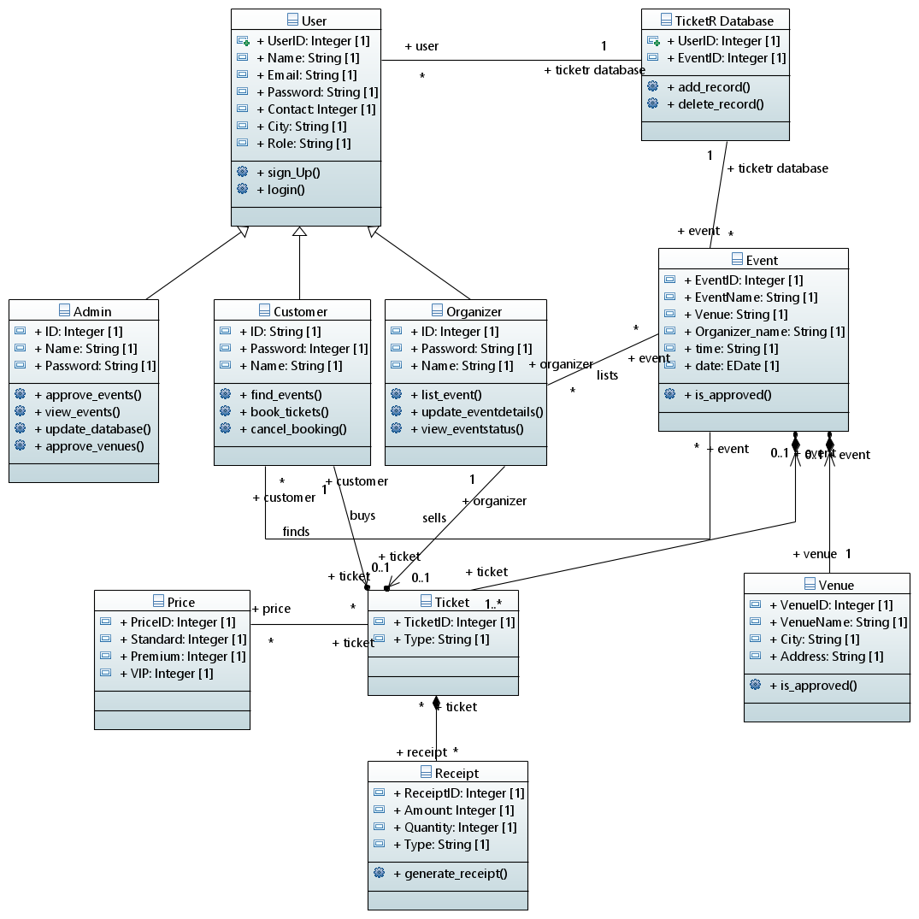
- Use Case

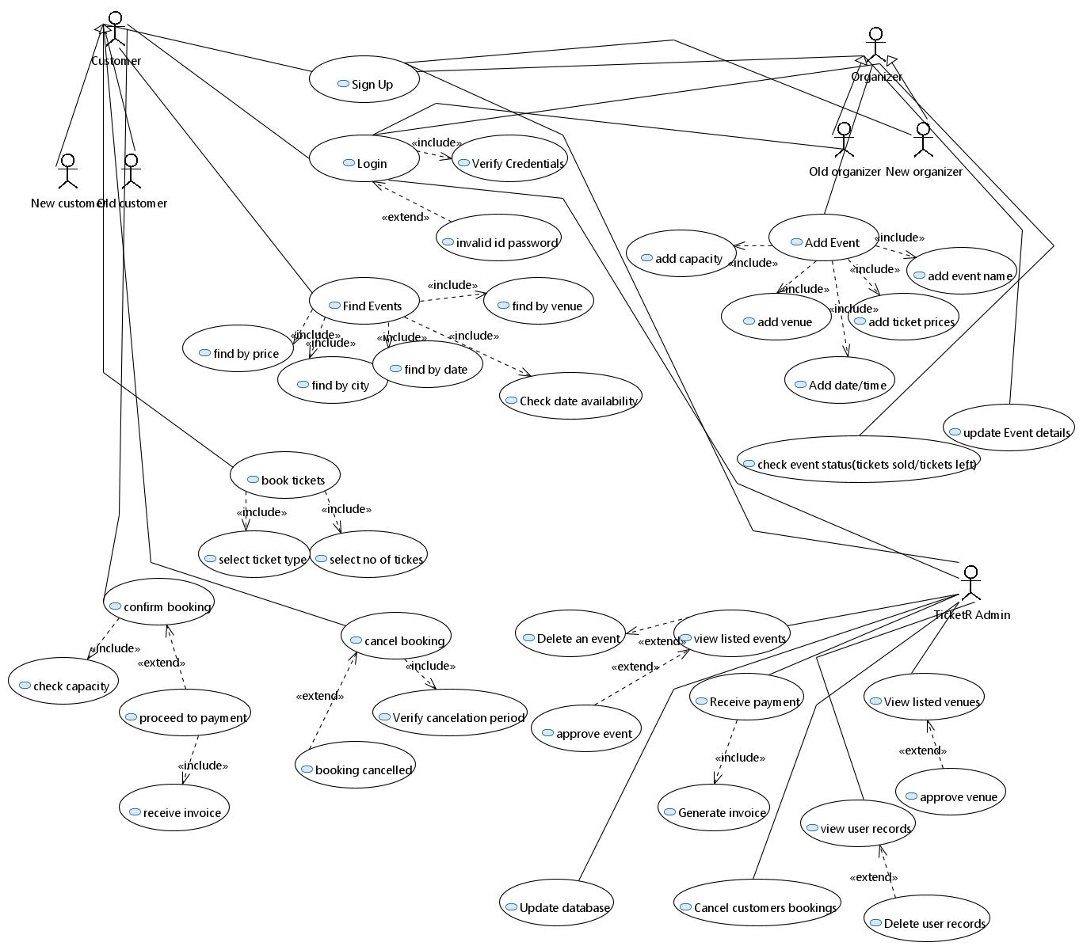

- Activity diagram
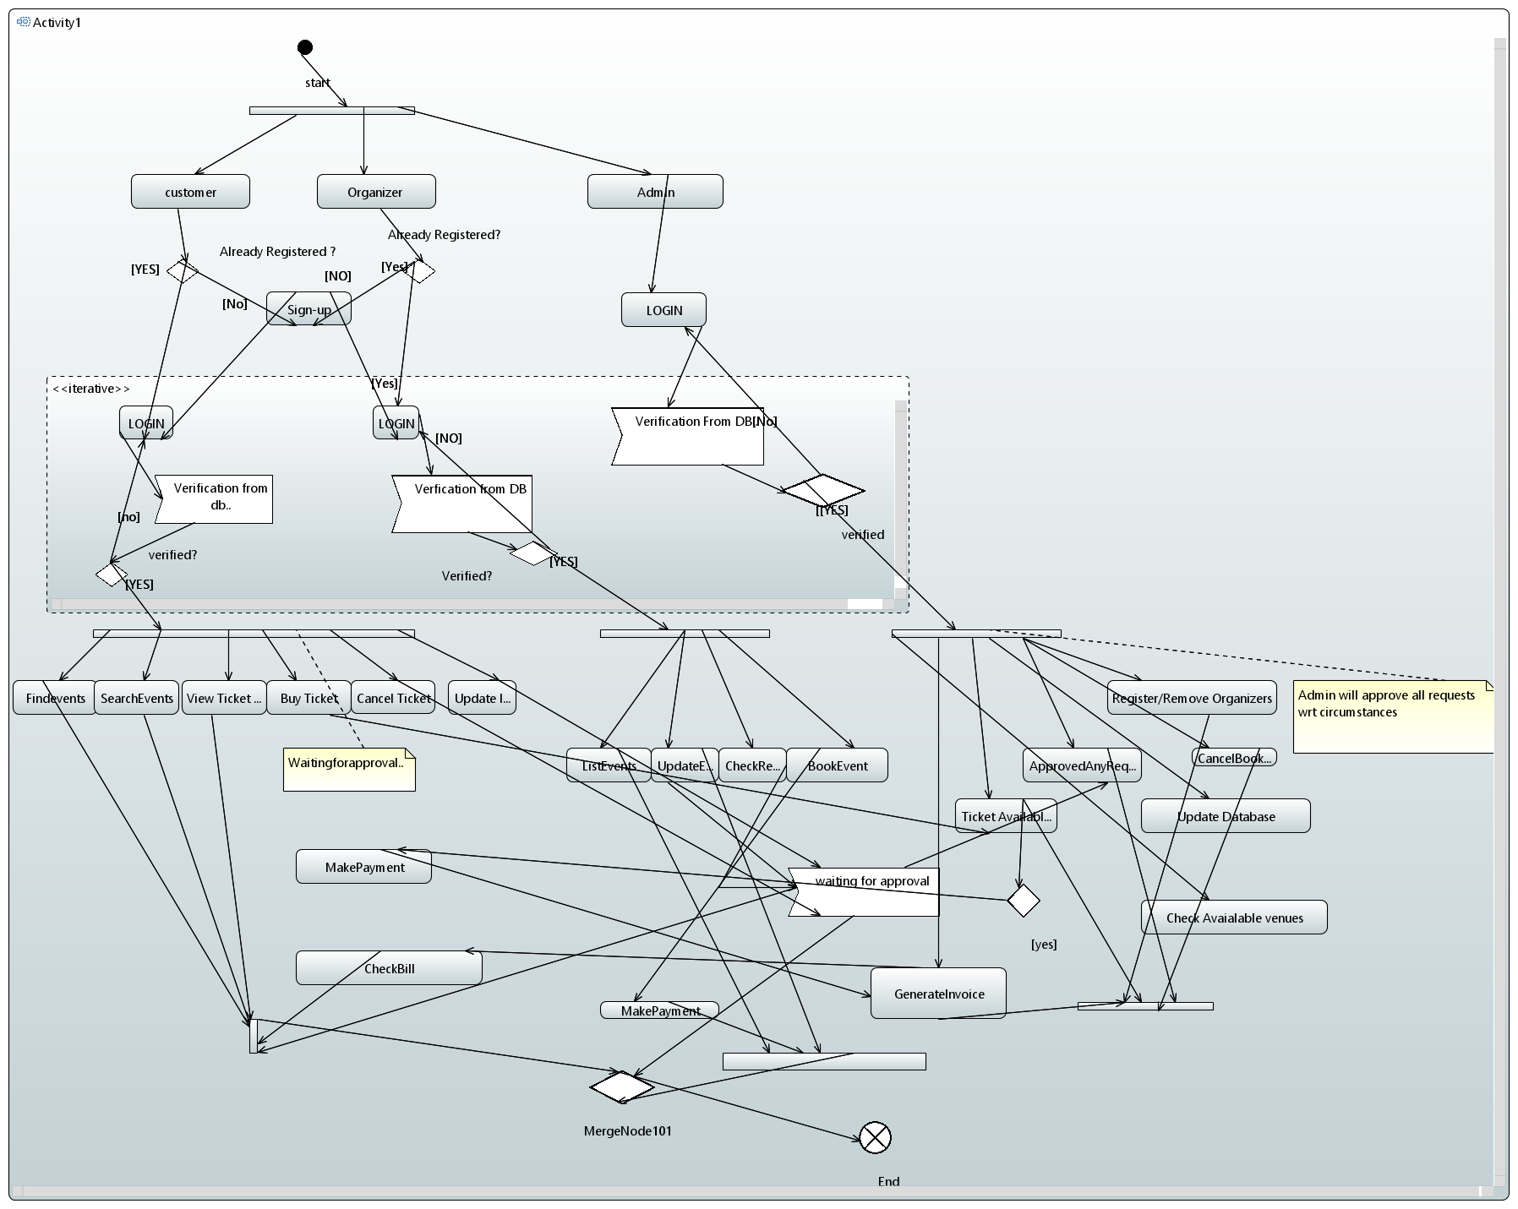
- Sequence Diagram

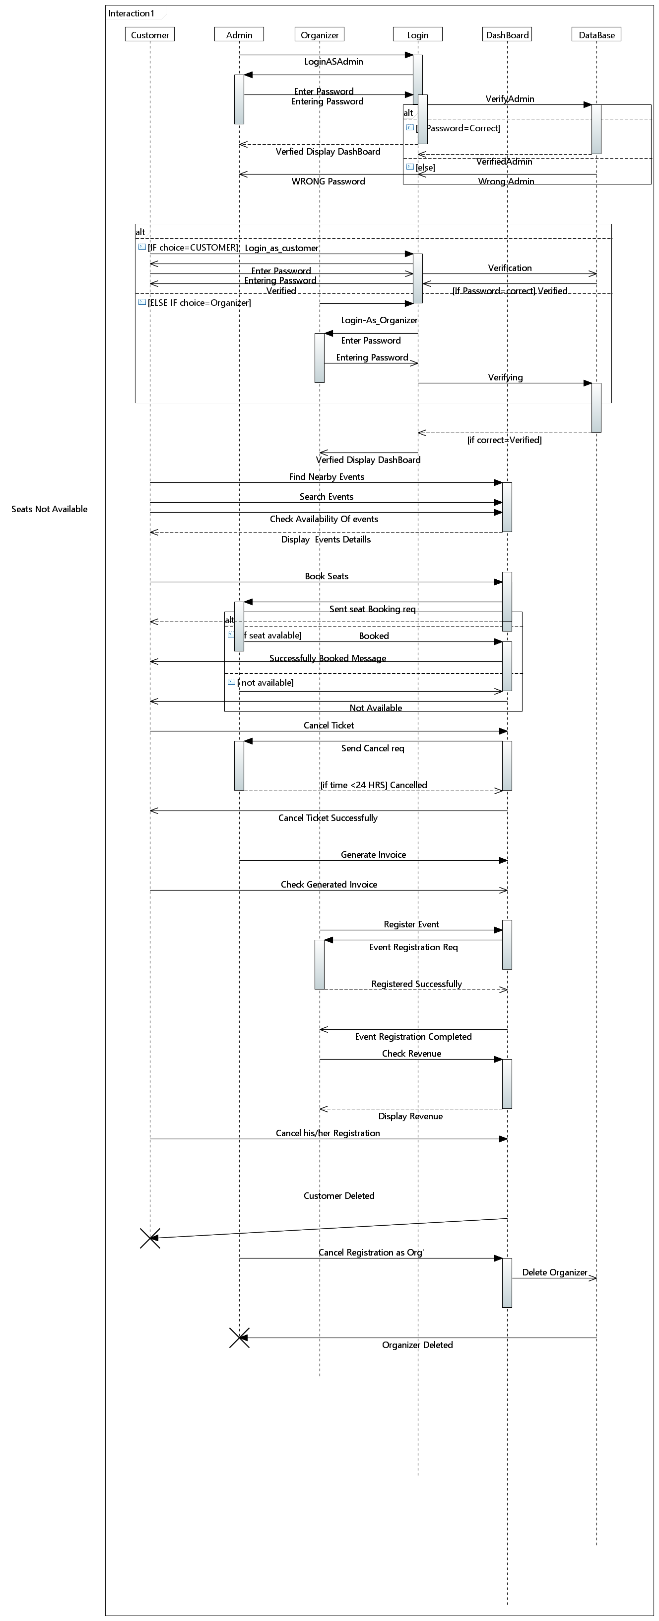

- Component diagram
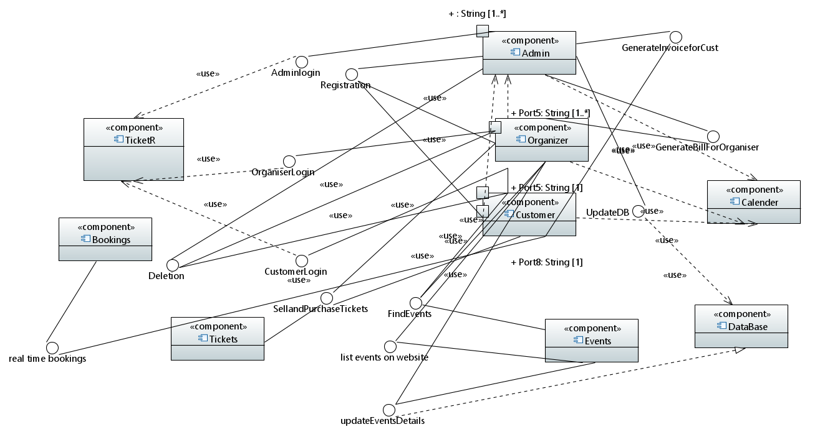
- Deployment Diagram

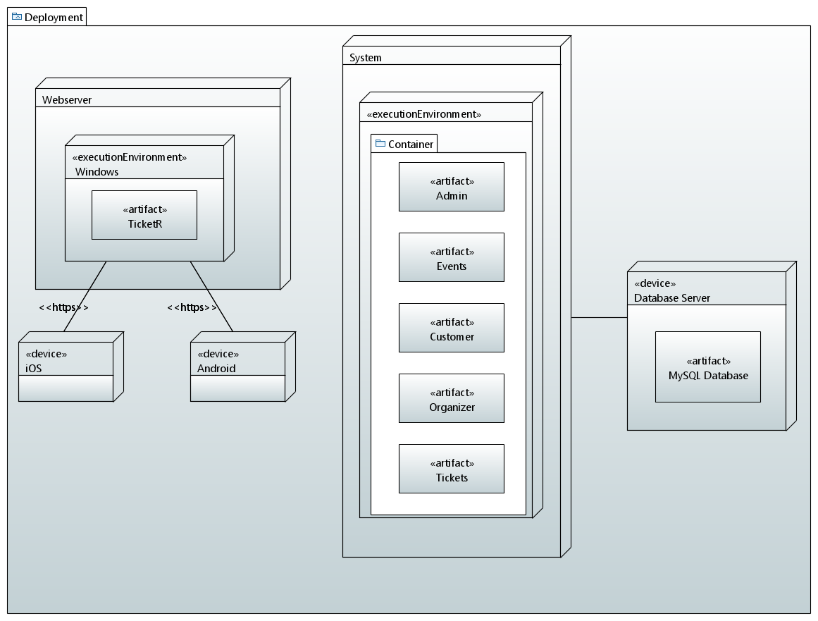
- State Diagram
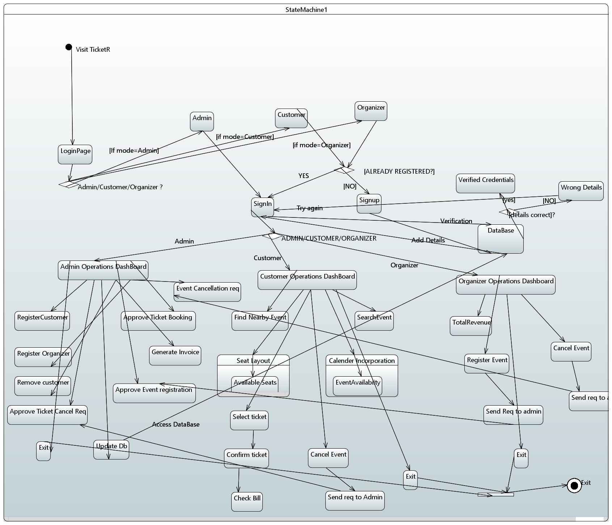

- Communication Diagram

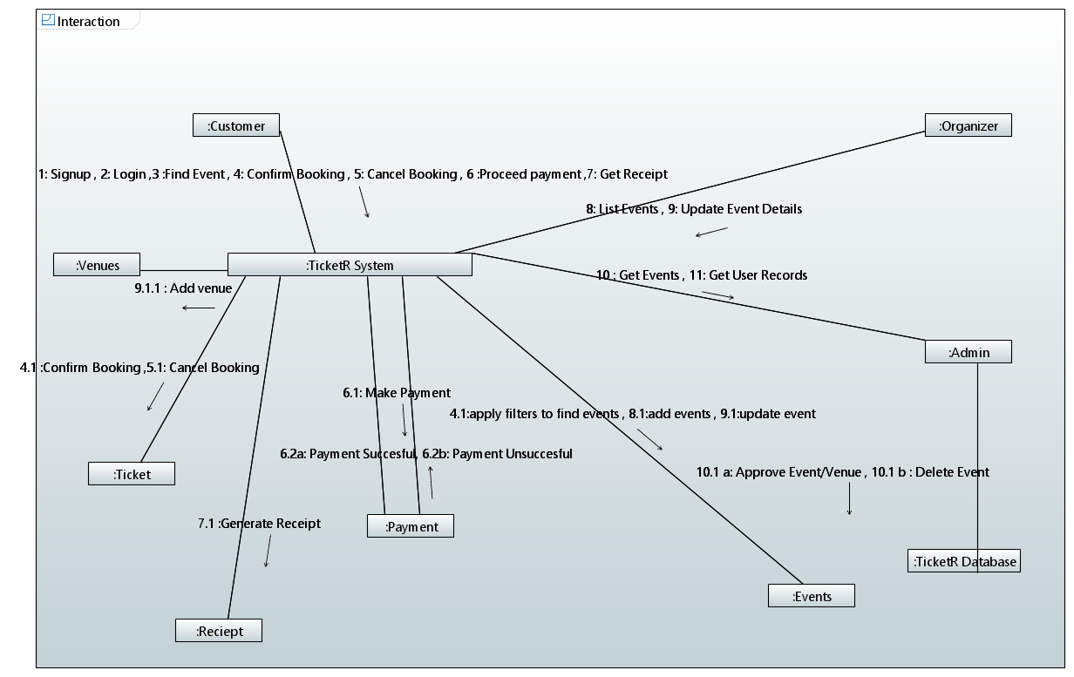
Appendix C: To Be Determined List
Not applicable

